Null Character / Terminator (\0)

Definition:
# Source: AI Source: Provided by: [Data Path: Persons Table -> ID Column: 1, Name_En Column: Motasem Essam] -> From: [Chatgpt (GPT‑5 Mini)] on [1/26/2026]
The null character, written as \0, is a special character used in programming to mark the end of a string. It tells the program where the string ends in memory.

Key Points
# Source: AI Source: Provided by: [Data Path: Persons Table -> ID Column: 1, Name_En Column: Motasem Essam] -> From: [Chatgpt (GPT‑5 Mini)] on [1/26/2026]
- It is not visible when the string is printed.
- It has an ASCII value of 0.
- Essential in languages like C and C++, where strings are represented as arrays of characters.

Why It’s Important
# Source: AI Source: Provided by: [Data Path: Persons Table -> ID Column: 1, Name_En Column: Motasem Essam] -> From: [Chatgpt (GPT‑5 Mini)] on [1/26/2026]
- Without the null character, the program would not know where the string ends.
- Prevents reading extra memory beyond the string, avoiding errors.

Example in C
# Source: AI Source: Provided by: [Data Path: Persons Table -> ID Column: 1, Name_En Column: Motasem Essam] -> From: [Chatgpt (GPT‑5 Mini)] on [1/26/2026]
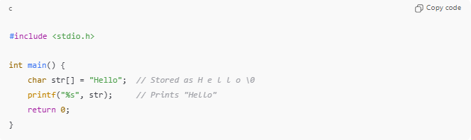
#include <stdio.h>

int main() {
char str[] = "Hello"; // Stored as H e l l o \0
printf("%s", str); // Prints "Hello"
return 0;
}
- Memory layout of str:
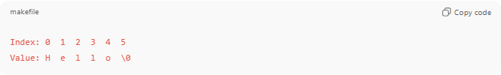
Index: 0 1 2 3 4 5
Value: H e l l o \0
- \0 marks the end of the string.

Example in C++
# Source: AI Source: Provided by: [Data Path: Persons Table -> ID Column: 1, Name_En Column: Motasem Essam] -> From: [Chatgpt (GPT‑5 Mini)] on [1/26/2026]
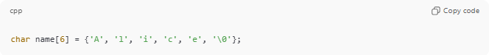
char name[6] = {'A', 'l', 'i', 'c', 'e', '\0'};
- Here, \0 ensures name is treated as a proper string.

Analogy
# Source: AI Source: Provided by: [Data Path: Persons Table -> ID Column: 1, Name_En Column: Motasem Essam] -> From: [Chatgpt (GPT‑5 Mini)] on [1/26/2026]
- String → A rope of beads
- Null character (\0) → Knot at the end of the rope, signaling no more beads beyond this point

✅ Summary
# Source: AI Source: Provided by: [Data Path: Persons Table -> ID Column: 1, Name_En Column: Motasem Essam] -> From: [Chatgpt (GPT‑5 Mini)] on [1/26/2026]
- Null character (\0) = special character marking end of a string.
- ASCII value = 0
- Critical for string handling in C and C++

